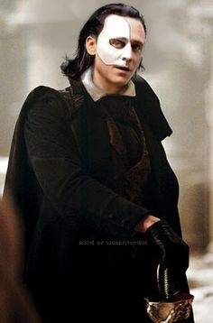
Physical description
Phantom of the opera is a man who looks older, has dark hair and fine eyebrows, has a rectangular face and does not usually smile, has no beard or mustache, wears a mask that makes it impossible to see his trace fine. he has big blue eyes. he has thin but very pretty lips. he has a slightly round nose but more pyramid-shaped,
He is quite an interesting man because of his physique and quite beautiful.

Personality
Personality is secretive, passionate, and controlling. A musical genius, the Phantom may hide in the walls of the Opera House, but he's certainly pulling its strings. Though generally a quiet poltergeist, he's willing to be more malevolent when he wants something.

